SCHOOL OF ELECTRICAL, ELECTRONIC AND COMPUTER ENGINEERING
ENEL3SF –SOFTWARE ENGINEERING 2
GROUP 10
NAMES | STUDENT NUMBER
MARINDI MPHO | 224019111
RAMAKOPA KOKETSO | 224060934
ZULU BONGA | 224043843
ZWANE BANELE | 224006427
NGCOBO SIBONELO | 224007550

Contents
1. Problem Definition 4
Problem 4
The main problems include: 4
Proposed Solution 4
Requirements 5
2.1 Functional Requirements 5
A. User Registration and Login: 5
B. Volunteer Opportunities: 5
C. Volunteer Matching: 5
D. Chatbot: 5
E. Notifications: 6
F. Attendance and Participation: 6
G. Administration: 6
2.2 Non-Functional Requirements 6
A. Performance: 6
B. Security: 6
D. Reliability: 7
E. Scalability: 7
F. Accessibility: 7
G. Maintainability: 7
H. Chatbot Quality: 7
3. Team Organisation and roles 8
Roles 8
Responsibilities 8
3. Prototype of the proposed solution 8
3.1 Administrator/ Organisations 10
3.1.1 Create Account 10
3.1.2 Dashboard 11
3.1.3 My Opportunities 11
3.1.4 Post an Opportunity 12
3.1.5 Profile 13
3.2 Volunteers 14
3.2.1 Create Account 14
3.2.2 Browse Opportunities 14
3.2.3 My Sign Ups 15
3.2.4 Profile 16
4. Risk Register 17
PROJECT CHARTER

Problem Definition

Problem
Community organisations often experience difficulties when managing volunteers, particularly because of their reliance on the usage of social media, spreadsheets, messaging platforms, and manual communication when recruiting and coordinating volunteers. This often results in difficulties such as locating suitable volunteers, keeping track of their information and maintaining effective communication.

The main problems include:
- Difficult Volunteer Matching: Organisations may struggle to find volunteers with the required skills, interests, and availability. At the same time, volunteers may have difficulty finding opportunities that are suitable for them.
- Lack of Verification: It can be difficult for volunteers to know whether an organisation is legitimate. This may reduce trust and create safety concerns.
- Manual Administration: Managing volunteer applications, schedules, attendance, and records manually can take a lot of time and may result in mistakes.
- Poor Communication: Important information such as schedule changes, reminders, and updates may not reach volunteers on time.
- Scattered Information: Volunteer and organisation information may be stored in different places, making it difficult to keep track of participation and project activities.

Proposed Solution
To address these problems, we propose a Community Volunteer Coordination System. The system will provide a central platform where volunteers and verified organisations can connect, communicate, and manage volunteer opportunities.
The main features of the system will include:
- Organisation Verification: Organisations will provide their registration number and registered name. An administrator will review the information before approving the organisation.
- Volunteer Matching: The system will use information such as volunteers' skills, interests, availability, and location to suggest suitable opportunities.
- Chatbot: A simple chatbot will assist users by answering common questions and helping volunteers find suitable opportunities.
- Notifications and Communication: The system will provide notifications for applications, reminders, schedule changes, and other important updates.
- Centralised Database: Volunteer profiles, organisation information, opportunities, applications, and attendance records will be stored in one system.

Expected outcome
The proposed system is expected to improve the way volunteers and community organisations connect and coordinate activities. It will help volunteers find suitable opportunities based on their skills, interests, availability, and location, while helping organisations manage volunteer applications, schedules, communication, and attendance more efficiently. The system will also improve trust through organisation verification and provide users with additional support through the Chatbot.

Requirements

2.1 Functional Requirements

A. User Registration and Login:
- Volunteer and organisation account creation, secure login, and logout.
- Profile creation and updating.
- Volunteer skills, interests, and availability specification.

B. Volunteer Opportunities:
- Opportunity creation and management by organisations.
- Opportunity details including location, date, time, required skills, and number of volunteers.
- Opportunity browsing, searching, and filtering for volunteers.
- Applications based on volunteer interests and availability.
- Application acceptance or rejection by organisations.
- Volunteer assignment lists for each opportunity.

C. Volunteer Matching:
- Volunteer-opportunity matching based on skills, interests, availability, and location.
- Relevant opportunity recommendations for volunteers.
- Matching volunteer profile visibility for organisations.

D. Chatbot:
- Integrated natural-language chatbot.
- Information on available and specific volunteer opportunities.
- Activity recommendations based on interests and availability.
- Guidance on registration and applications.
- Reminders for upcoming activities.
- Platform navigation assistance.
- Frequently asked questions and answers.
- Human administrator referral when the chatbot cannot provide an appropriate answer.
- Relevant emergency and important contact information when required.

E. Notifications:
- Application acceptance and rejection notifications.
- Reminders for upcoming volunteer activities.
- Notifications regarding opportunity changes or cancellations.
- Organisation notifications when volunteers submit applications.

F. Attendance and Participation:
- Volunteer attendance and completed activity records.
- Volunteer participation history.
- Post-activity volunteer feedback.

G. Administration:
- Registered user management.
- Review of reported users and content.
- Removal of inappropriate volunteer opportunities.
- Monitoring of overall system activity.
- Platform safety and management.

2.2 Non-Functional Requirements

A. Performance:
- Normal page loading within 3 seconds.
- Search results displayed within 2 seconds under normal operating conditions.
- Chatbot responses within 5 seconds where possible.
- Simultaneous access by multiple users without significant performance issues.

B. Security:
- User security and data protection.
- Secure password storage using appropriate password-hashing methods.
- Role-based access to information and system functions.
- Protection of personal information from unauthorised access.
- HTTPS-secured communication between users and the server.
- Automatic logout after a suitable period of inactivity.

C. Usability:
- Simple, intuitive, and user-friendly interface.
- Easy access to main functions without extensive training.
- Easily accessible and simple-to-use chatbot.
- Clear and understandable error messages.

D. Reliability:
- Reliable access to volunteer opportunities.
- Continuous availability when opportunities need to be accessed.
- Prevention of lost applications and participation records.
- Appropriate recovery from unexpected system failures.

E. Scalability:
- Addition of users and organisations without major platform changes.
- Increasing numbers of volunteer opportunities as the system grows.

F. Accessibility:
- Readable text and clear navigation.
- Information that does not rely on colour alone to communicate meaning.
- Responsive interface.
- Usability across desktop and mobile devices.

G. Maintainability:
- Modular architecture for independent component updates.
- Properly documented source code.
- Consistent coding standards.
- Updatable chatbot knowledge base and responses without rebuilding the entire system.

H. Chatbot Quality:
- Accurate, reliable, and user-friendly assistance.
- Understanding of common question variations.
- Conversation context maintained where practical.
- Simple and understandable language.
- Clear indication when an answer cannot be provided.
- Avoidance of misleading information.
- Protection of users' personal information.
- Prevention of unnecessary exposure of private data.

3. Team Organisation and roles
The project team will be organised according to the responsibilities required to develop and manage the Community Volunteer Coordination Platform.
Roles | Responsibilities
Volunteer | - Create the profile  - View activities available  - Choose the area where they want to volunteer at.  - Apply for activities
Volunteer Coordinator | - Creates projects  - Approve the volunteers  - Assign activities
Project Manager | - Plan activities  - Give updates about the project statues  - Manage the assigned volunteers
Organization Manager | - Monitor the progress of the project.  - Advertise the community project
System Administrator | Manage the:  - System users  - System settings and security  - Database maintenance
Developers | Responsible for:  - Designing  - Implementing  - Testing  - Maintenance
Project Sponsor | Responsible for:  - Funding  - Defining the project goals  - Makes major project decisions

Prototype of the proposed solution
This prototype represents design of the proposed platform and comprises twelve screens, structured according to two distinct user roles the Volunteer and the Organisation Administrator. The design is oriented around a single core interaction cycle an organisation publishes a volunteer opportunity, a volunteer registers for participation, and both parties are subsequently able to monitor the outcome of that engagement.
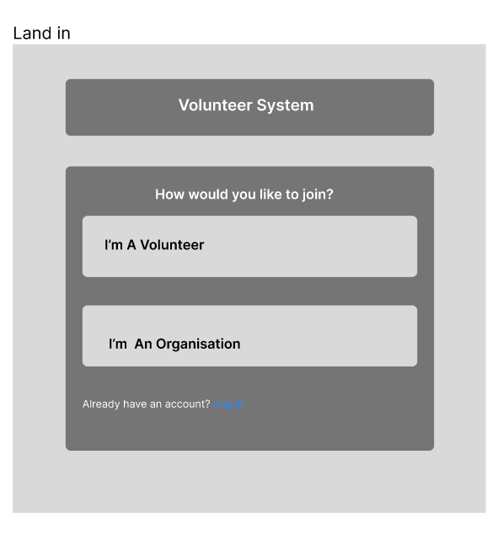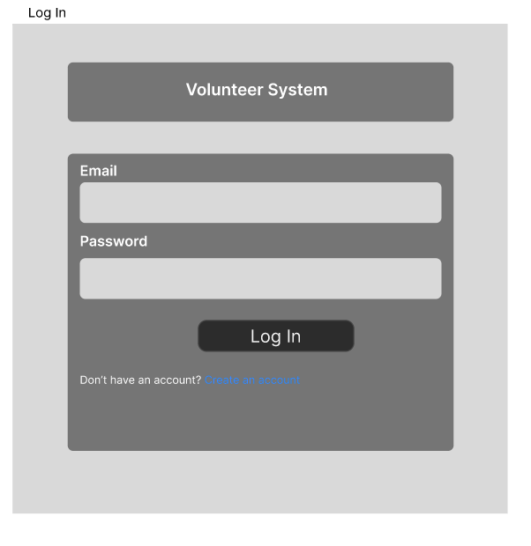
Figure 1.1 Figure 1.2

Figure 1.1 if the first screen that a visitor sees it allows them to choose the role they want to sign up for.
- “I’m A Volunteer” this option routes the user to the volunteer sign-up form.
- “I’m An Organisation” this option routes the user to the organisation sign-up form.
- “Already have an account? Log in” this option is for returning users who already have an account they can use it to be redirected to the log in screen.
Figure 1.2 is the logging in screen for both roles; the system detects the user’s role after authentication then directs them to correct screen.
- There is an email and password field where users insert the ones they used to create an account.
- “Don’t have an account? Create an account” I return to the landing screen (Figure 1.1) if the user doesn’t have an account.

3.1 Administrator/ Organisations

3.1.1 Create Account
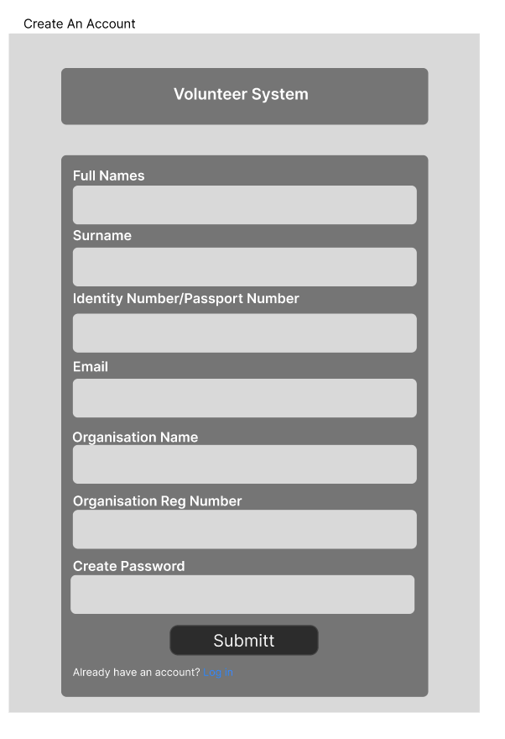
Figure1.3
This page collects all the information for the organisation and the names of the administrator responsible for it.
- It requires the name, surname, email and identity number of the administrator.
- Organisation name and organisation registration number is required.
- A password for the account must be created.
- “Already have an account? Log in” this option is for returning users who already have an account they can use it to be redirected to the log in screen.

3.1.2 Dashboard
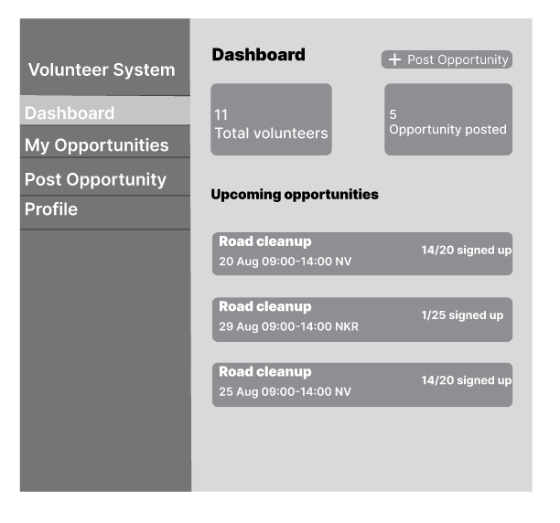
This screen is the landing page for an organization after admin’s login.
- It has summary stat cards that shows the total number of volunteers that have worked with the organisation and the number of opportunities that the organisation has posted.
- It shows the list of upcoming opportunities with all its details.
- “+ Post Opportunity” it’s a button that directs the admin to the page that adds opportunities.

3.1.3 My Opportunities
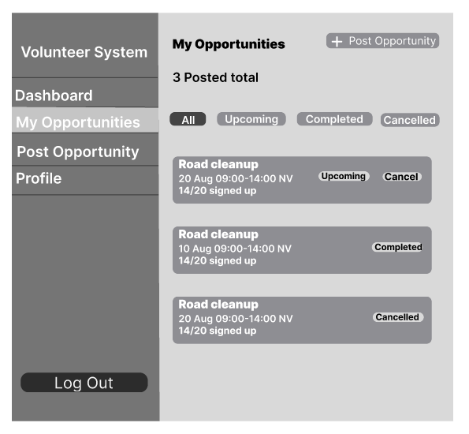
Figure 1.5
The organization’s full listing history, with status filtering so the page stays usable once an organization has posted many opportunities over time.
- Filter pills: All / Upcoming / Completed / Cancelled
- Each row shows status, date/time, location, and spots filled
- “Cancel” only appears on Upcoming rows

3.1.4 Post an Opportunity
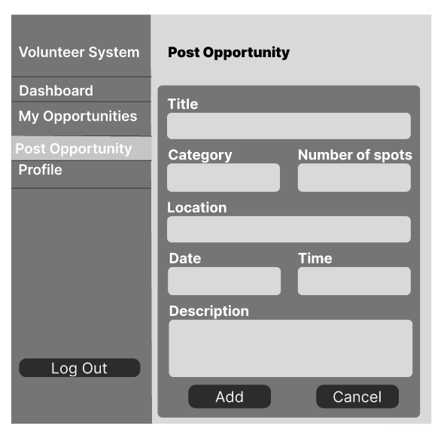
Figure 1.6
This page has a form to add all the details about a new opportunity the admin wants to create.
- Title, category, number of spots, location, date, time, and description are required
- “Publish opportunity” goes live immediately for volunteers to see

3.1.5 Profile
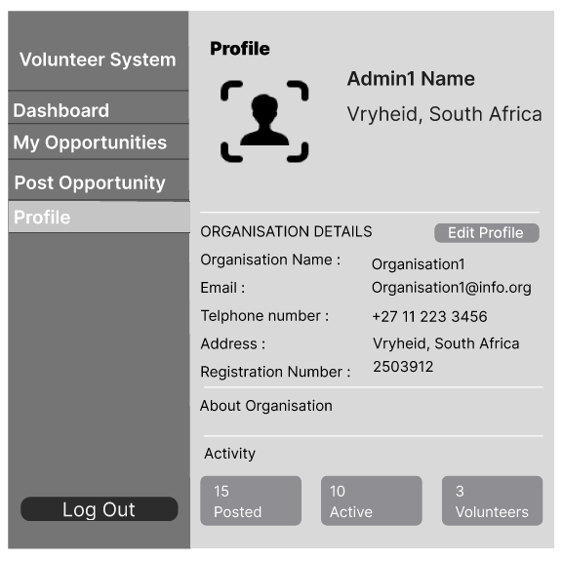
Figure 1.7
This page shows the information of the organisation and allows the administrator to edit it.

3.2 Volunteers

3.2.1 Create Account
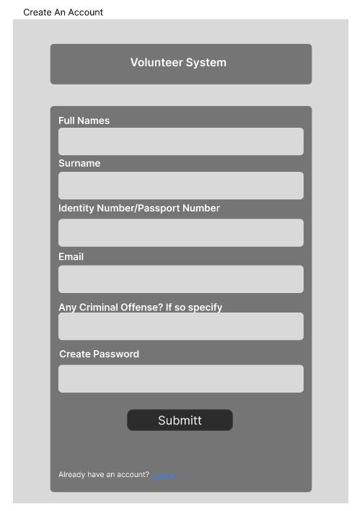
Figure1.8
This screen captures information about the volunteer to create an account for them.
- Full names, surname, email.
- A volunteer must add a criminal record if they have any.
- A password for the account must be created.
- “Already have an account? Log in” this option is for returning users who already have an account they can use it to be redirected to the log in screen.

3.2.2 Browse Opportunities
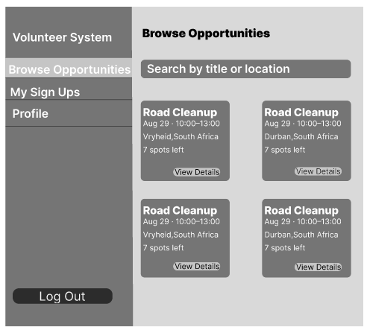
Figure 1.9 Fugure 2.1
Figure 1.9 is the volunteer’s landing page after login. A search bar and category filter sit above a card grid so volunteers can scan many opportunities quickly.
- Search by title, or location
- Each card shows category, title, host organization, date/time, location, and spots remaining.
- “View Details” the button opens the opportunity details.
Figure 2.1 is the page that show the more details of the posted opportunity when the button “View Details” is pressed.

3.2.3 My Sign Ups
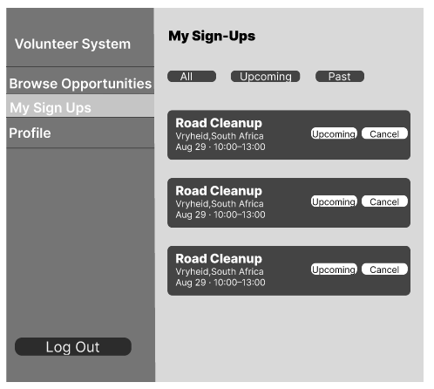
Figure 2.2
The volunteer’s personal record of commitments and history.
- All / Upcoming / Past tabs, matching the filter-pill pattern used on the organization’s My Opportunities screen.
- Each row shows a date badge, title, and status.

3.2.4 Profile
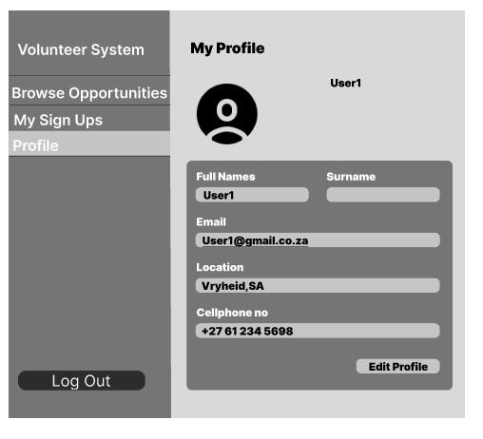
Figure 2.3
Let’s a volunteer keep their identity updated since organizations rely on this information when reviewing sign-ups.
- Editable name, email, and location fields

4. Risk Register
RISK ID | RISK DESCRIPTION | Category | Likelihood  (L/M/H) | IMPACT  (L/M/H) | RISK SCORE | MITIGATION STRATERY
R1 | Data breach/ Security compromise: Unauthorized access to volunteer and organization personal identifiable information such as contact details availability and interests. | Security | M | H | High | - Conduct regular security audits and vulnerability scans  - Ensure strict adherence to data protection laws for example the POPIA ACT must be followed  - Strong encryption such as hashing for passwords and the HTTPS must be implemented
R2 | Inaccurate Volunteer Project matching: The software’s matching algorithm does not accurately match volunteers’ skills and preferences with suitable projects. As a result, the system may recommend irrelevant opportunities or fail to identify suitable ones, leading to volunteer frustration, wasted time, and reduced efficiency for programme coordinators. | Functional | M | H | High | - The system must allow volunteers and organizations to manually search for opportunities and if necessary, they should be able to override the system’s recommendations  - A feedback feature must be built so that it will allow the users to tell us if the match was good or bad and this can be used to improve the logic of the system  - Define the matching rules clearly with the client before coding begins
R3 | Poor user adoption and low engagement: Volunteers and organizations may find the system to be difficult to use and time consuming and this may discourage them from using the platform regularly | Usability | H | M | High | - Design a simple and user-friendly interface that is easy for both volunteers and organisations to understand.  - Provide basic instructions, FAQs, and short tutorials to help users learn how to use the system.  - Test the system with a small group of volunteers and administrators to identify problems and improve the user experience before the final release
R4 | Chatbot Error: The chatbot can share false, misleading information or harmful details that break the users trust | Functional | M | M | Medium | - Test the chatbot regularly using common questions that users are likely to ask.  - Clearly inform users when the chatbot cannot understand or answer a question and provide an option to contact a human coordinator.  - Keep the chatbots information simple and organised so that the team can be able to update it when needed
R5 | System downtime: The system may become unavailable or crash when many users access it at the same time. This can prevent volunteers and organizations from signing up, checking schedules and finding opportunities. | Technical | M | M | Medium | - Keep regular backups of important data so the system can be restored if a failure occurs  - A reliable cloud hosting service must be used to keep the system available ‘  - The system must be able to handle many users accessing it at the same time  - The system must be monitored regularly to identify and fix problems early
R6 | Verification process failure: The organisation verification process may not be strong enough, allowing fake or unverified organisations to join the platform. This could reduce trust in the system and create safety risks for volunteer | Security | M | M | Medium | - Require organisations to provide valid registration details before they can join the platform.  - Allow an administrator to manually check and approve organisations before they are allowed to use the system  - Provide clear requirements for organisation registration.  - Add a “Report Organisation” feature so users can report organisations that appear suspicious or unverified.
R7 | Increasing Project Scope: New features and requirements may be added during development, and this will make the project to be larger than what was originally planned. This can lead to delays, increased costs and difficulty in completing the project on time. | Project | H | L | Medium | - Follow the agreed project requirements and avoid adding unnecessary features during development.  - Discuss and evaluate any new feature before adding it to the project.  - Prioritise the most important features first to ensure the project is completed on time.
R8 | Lack of Legal and Compliance Requirements: The system might not meet the relevant laws and regulations for volunteer work, user safety and data policy. This could lead to legal problems, and it could reduce users trust in the platform | Legal/ Compliance | M | M | Medium | - Review the system’s terms of service, privacy policy, and data handling rules to ensure they meet relevant requirements.  - Create clear rules for user behaviour and volunteer safety.  - Make sure the team understands and follows the required data privacy and safeguarding procedures.
R9 | Inaccurate Volunteer Information: Volunteers may not regularly update their profiles, such as their skills and availability. This can cause the system to recommend unsuitable opportunities and reduce the effectiveness of the matching process. | Data | M | L | Low | - Send regular reminders to volunteers to update and review their skills and availability  - The profile update process must be easy to use  - Volunteers must be encouraged to keep their information up to date so that they receive opportunities that are suitable for them
R10 | Poor Performance Under High Load: The chatbot or search function may become slow or unresponsive when many users access the system at the same time. This can make it difficult for users to find opportunities or get help from the chatbot. | Technical | L | M | Low | - Use a database that can handle many users and requests.  - Keep the search function simple and efficient to improve response times.  - Test the system with many users before launch to identify and fix performance problems.

Purpose of the Risk Register
The purpose of the risk register is to identify the possible problems that could potentially affect the system during and after its competition.
For each risk, the following criteria is employed:
- Likelihood: This shows how likely the risk is to happen. We rated it as Low, Medium, or High based on how realistic the risk is and the conditions in which our system will operate.
- Impact: This shows how serious the consequences would be if the risk occurred. We considered factors such as user experience, trust, legal issues, delays, and the overall performance of the system.
- Reason: This explains why we gave the risk its likelihood and impact ratings. It helps the reader understand how we reached our decision.
- Risk Score: This combines the likelihood and impact to show how important the risk is. High risk items need more attention, medium-risk items should be monitored and managed, while low risk items are less urgent.
- Mitigation Strategy: This explains what we can do to prevent the risk or reduce its effects if it happens. The strategies were kept practical and achievable based on our level of experience as beginner developers.
Overall, the risk register helps us identify potential problems early and plan how we can manage them before they negatively affect the project.

PROJECT CHARTER
PROJECT TITLE: COMMUNITY VOLUNTEERING PLATFORM

Schedule/Stages
Week 1:
- Team Discussion: Problem discovery, stakeholder analysis and team organization (Teams meeting).
- Submission: Project charter, problem statement, roles and risk register. By Saturday 22 August 23:55.
Week 2:
To Be Updated

Scope
- Must be accessible and operated on stakeholder’s computer/Cell.
- Will be deployed as a Progressive Web Application (PWA).
- Must utilize a relational database. i.e PostgreSQL.
- Communications will be restricted automated emails and notifications (no direct in-app messaging).

Budget
Rough Estimates
Local development: R175 000 – R340 000
Annual Operational costs: R65600 – R130 400

Target Quality
Project completed and submitted by the final due date with (80-100) % of success criteria achieved.

Course Lecturer / Advisor
- Dr Jules-Raymond Tapamo

Team Members
- (223068894) Mpho Marindi (Team leader)
- (224060934) Koketso Ramakopa
- (224043843) Bonga Zulu
- (224006427) Banele Zwane
- (224007550) Sbonelo Ngcobo

Problem Statement
- There is a lack in efficiency in recruitment and management for volunteering services in communities. Hours are not properly accounted for and volunteer efforts aren’t coordinated efficiently.

Business Care
- To co-ordinate and facilitate community volunteering operations to better community living standard.
- To improve volunteering service efficiency and safety.

Goal Statement
To improve community volunteering service delivery and create opportunity for growth.

Roles
 | Week - 1 |  | Week – 2 | Week – 3 | Week - 4
 | Items
(223068894) Mpho Marindi (Team leader) | Problem Statement
(224060934) Koketso Ramakopa | Use Case Definitions
(224043843) Bonga Zulu | Requirements Definitions
(224006427) Banele Zwane | Prototype
(224007550) Sbonelo Ngcobo | Project Management Charter

